Software Engineering & Project
Snapshot Week 3 - BLOCK UG-16
Maptek, Block Model Compression Algorithm



Name | Student ID
Adam Dao | a1797499
Calvin McCann | a1860428
Hamidur Rahim Mahir | a1914792
Izak Stentiford | a1822100
Mohammed Ali Rezaei | a1714717
Pezhman Beheshtian | a1661736
Tyler McKinley | a1716769
Yuzhe Ma | a1918429

Product Backlog and Task Board
Product Backlog
Task | Description
Compression Algorithms Research | Research compression algorithms and create a document sharing the findings with the rest of the team
Titan Acceptance Test | Create a python file that implements the stream processor converting the input format to the output format and submit to Titan
Titan Initial Submission | Create a python file that implements the stream processor as well as a compression algorithm and submit to Titan
Snapshot 1.1 | Create snapshot 1.1
Initial Report | Create initial report
Improved Submission | Create a python file that improves on the initial submission through a faster algorithm or a more efficient algorithm

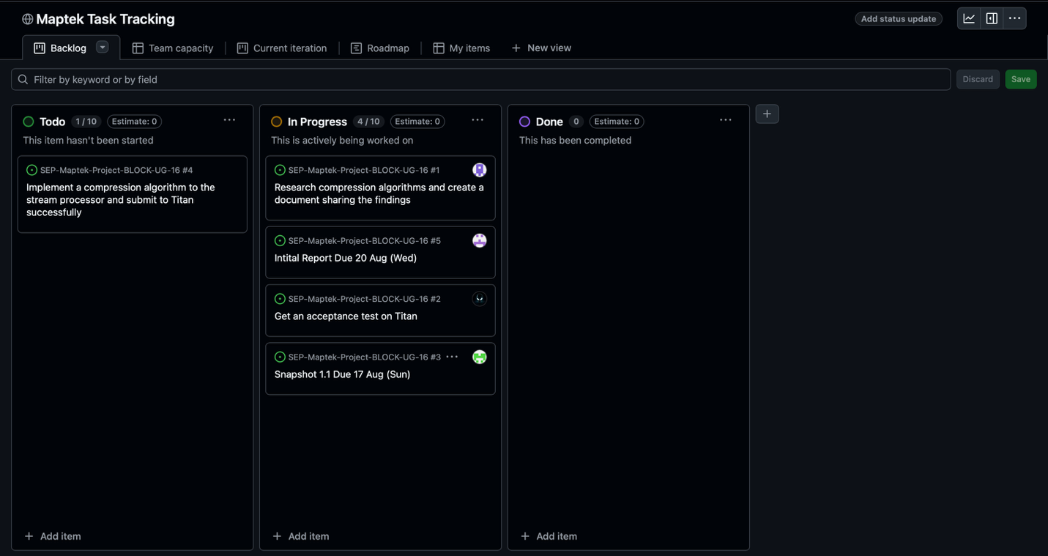
Task Board

Sprint Backlog and User Stories
Sprint Backlog
Task | Description
Compression Algorithms Research | Research compression algorithms and create a document sharing the findings with the rest of the team
Titan Acceptance Test | Create a python file that implements the stream processor converting the input format to the output format and submit to Titan
Titan Initial Submission | Create a python file that implements the stream processor as well as a compression algorithm and submit to Titan
Snapshot 1.1 | Create snapshot 1.1
Initial Report | Create initial report

User Stories (Sprint 1)

As a developer, we want to research existing compression algorithms so that our team can choose an efficient method for compressing block models.

As the Product Owner (TA), I want a minimal Python script that can run on Titan without errors so that I can confirm the input/output pipeline works correctly before adding complex compression.

Definition of Done
Complete the Titan Initial Submission task which involves a working submission on Titan that implements the stream processor and compression algorithm.

Summary of Changes
This week marked the kick-off of the project. The group set up communication channels, version control, and task tracking tools. The product backlog and sprint backlog were finalized, and research into compression algorithms was conducted to support future development. The team also began drafting the initial report and group charter, outlining roles and responsibilities. However, a significant obstacle was encountered: despite having received the Titan access password, the group was unable to log in to Titan, which has blocked progress on initial testing. The team is actively seeking a resolution to this access issue while continuing research and documentation work

